Name: V Akhil id no: 2520080029
Course: ossp section: 10 skill week 4

Task 1:
To Split Input into Tokens, Identify Delimiters, Handle Whitespace, Create Token Structures, Validate Token Streams, Debug Parsing Output and Design Parser Logic, Generate Parse Trees, Validate Syntax, Detect Errors, Handle Empty Commands, Produce Execution Structures

Output
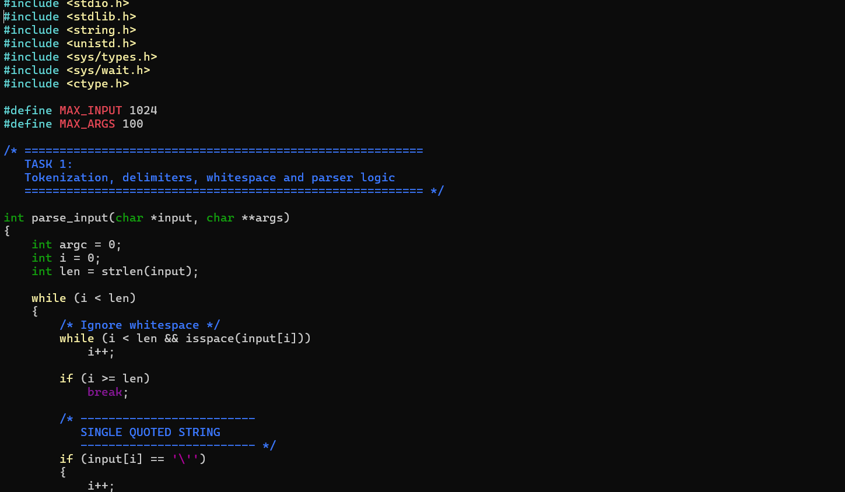
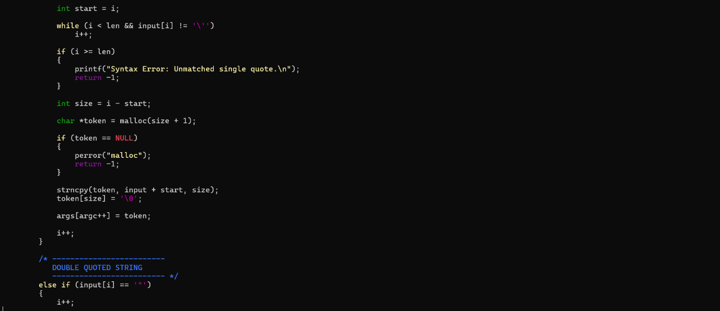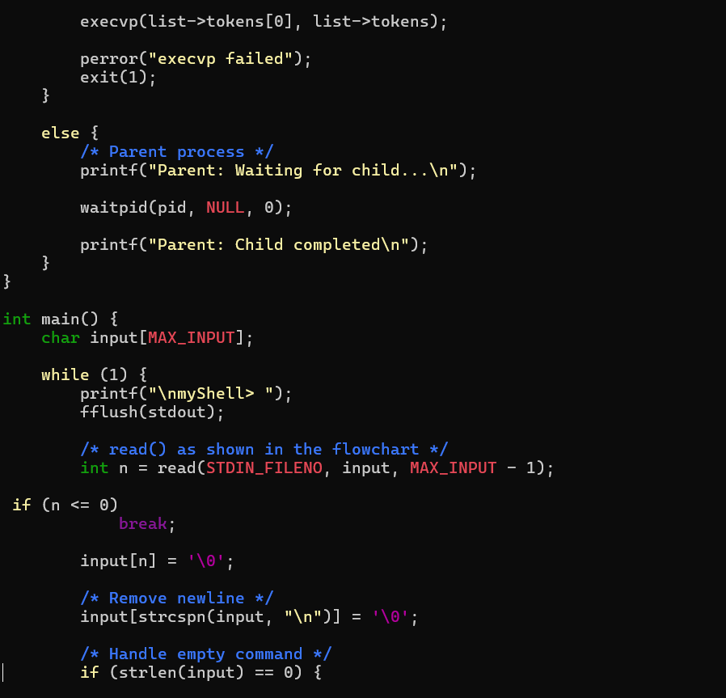

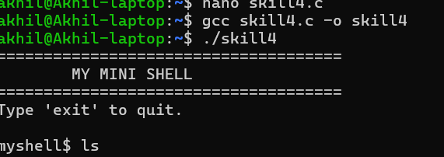
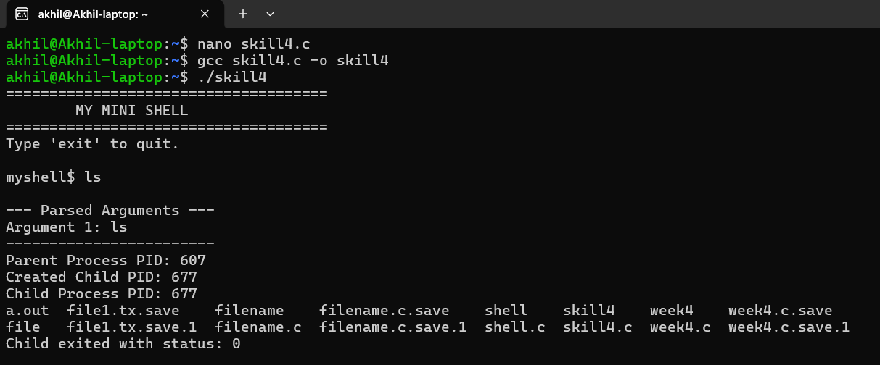
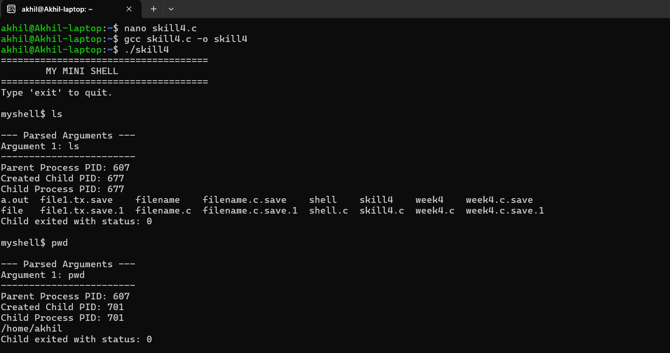

Task 2:
To Apply Single Quotes, Preserve Literal Content, Ignore Variable Expansion, Store Quoted Strings, Validate Parsing Results, Test Edge Cases.

Output

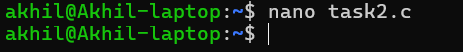
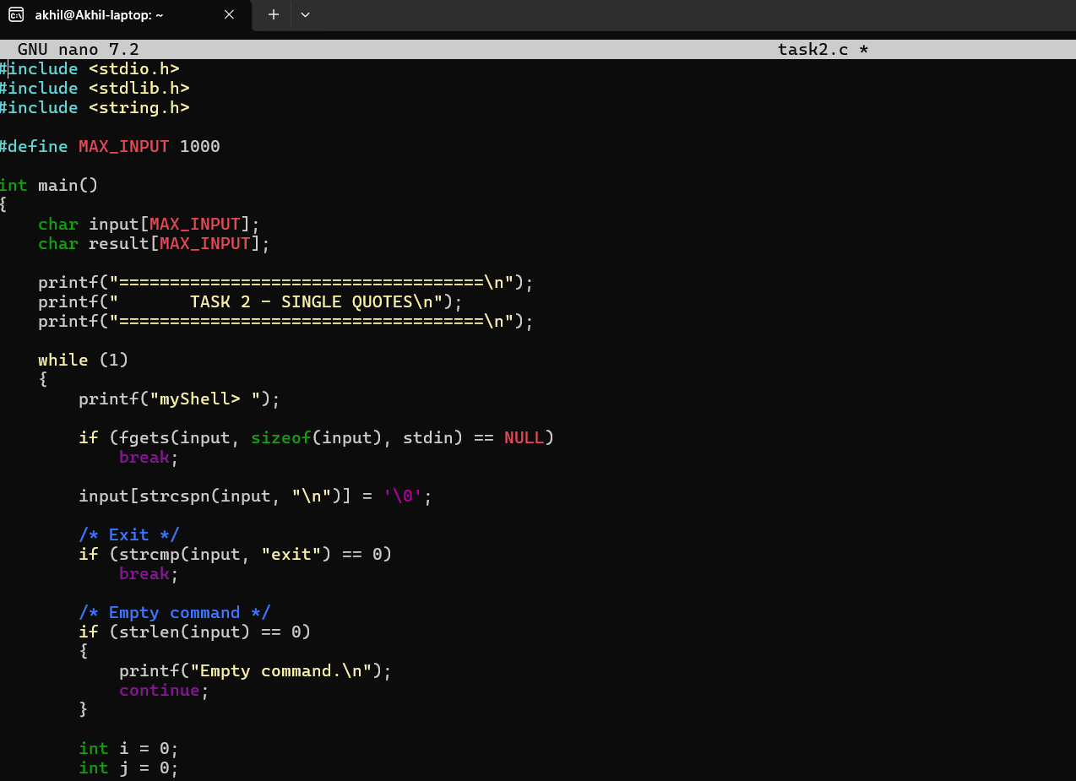
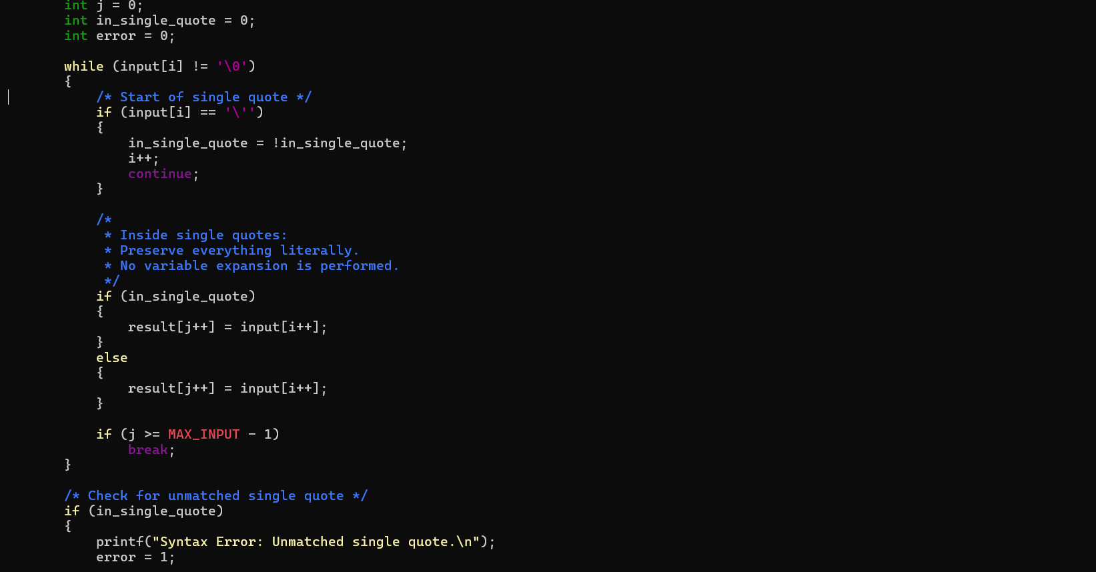
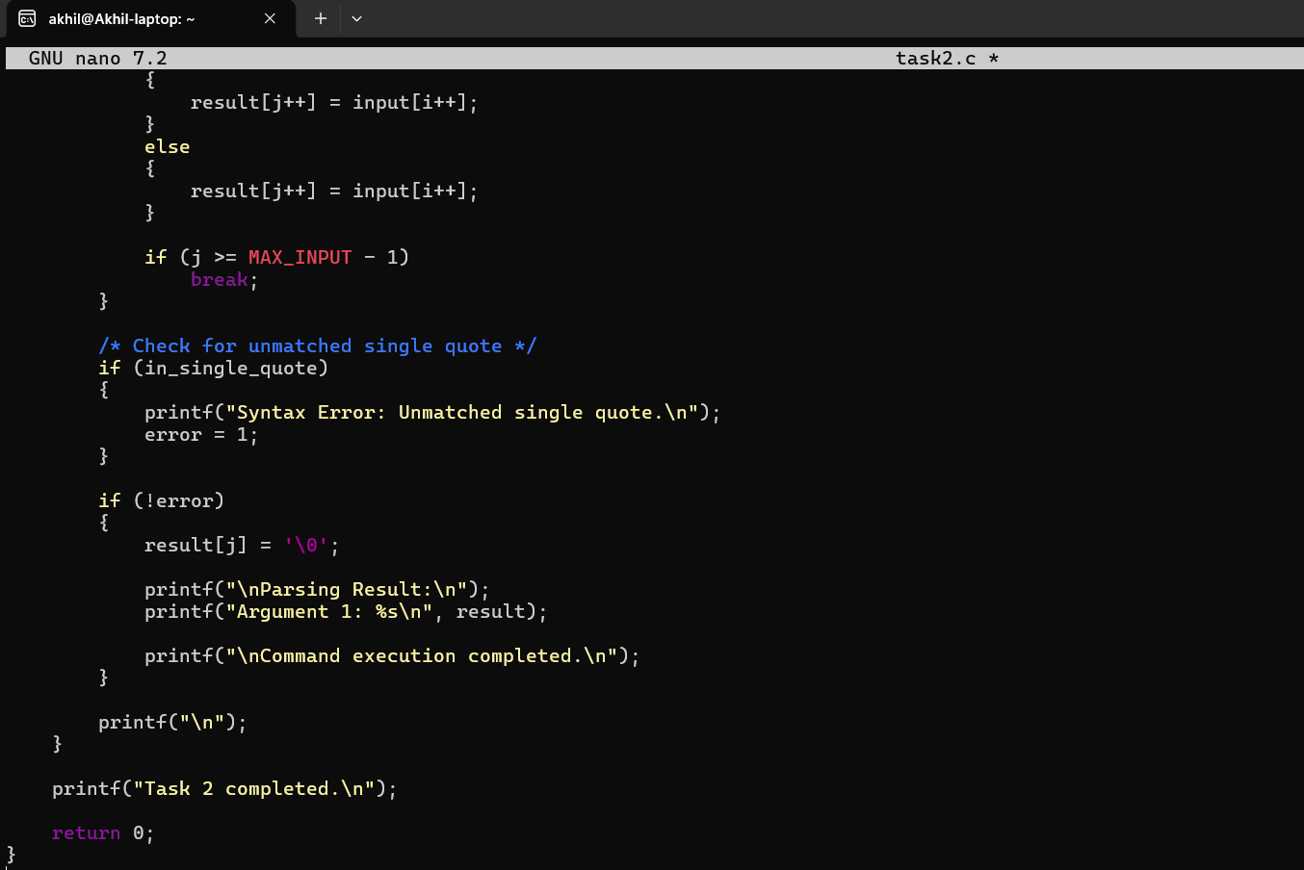

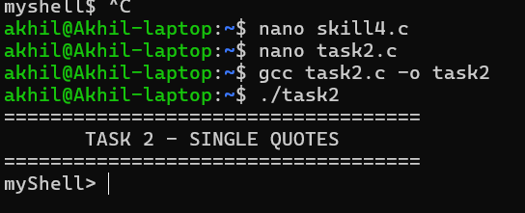
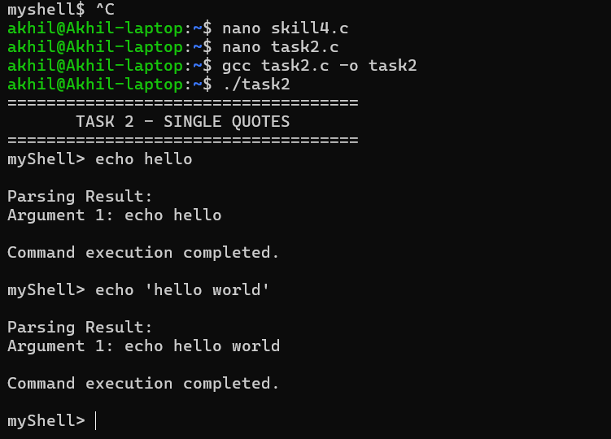
Task 3:
To Apply Double Quotes, Preserve Spaces, Allow Variable Expansion, Parse Nested Tokens, Validate Outputs, Test Quoted Commands.

Example Output:

Case1:
myShell> echo "Hello $USER"

--- Parsed Arguments ---
Argument 1: echo
Argument 2: Hello raghu

Child Process
PID = 3022

Hello raghu

Child process completed.

Case2:

myShell> echo "Hello World

Syntax Error: Unmatched double quote.

